2-minute Quotes Read Me

In addition to our near end-of-day options quotes, greeks and theoretical price data, we offer raw options market information snapped with underlying prices every two minutes during the trading day. These files are zipped and are available at 7:30 pm EST after the close.
The 2-minute snapshots have history back to 2015 (our our near end-of-day options quotes go back to 2007).

Column Headers
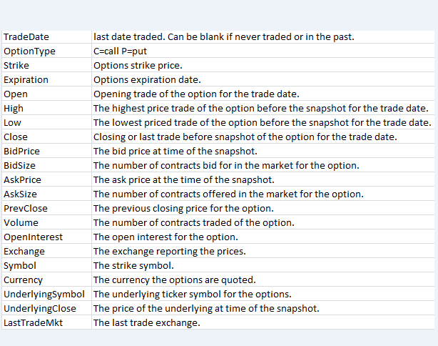
Equity File Sample
Column Header | Example | Description
last_mkt | NMS | The exchange reporting the last trade.
ticker | AAPL | The underlying ticker symbol for the options.
trade_date | 20190819 | The last date traded. Can be blank if never traded.
bid_price | 211.93 | The underlying bid price at time of snapshot.
Blank |  | Blank
ask_price | 211.95 | The underlying ask price at time of snapshot.
Blank |  | Blank
volume | 10236526 | Underlying volume at the time of the snapshot.
open | 210.62 | Opening underlying price.
high | 212.7307 | High price of the day up to the time of the snapshot.
low | 210.025 | Low price of the day up to the time of the snapshot.
close | 211.94 | Last price of the day up to the time of the snapshot.
prev_close | 206.5 | Prior close of the underlying.

Errata

We had problems with our provider and getting started in Jan 2015 and only have 12 of 20 trading days.
Here’s a screenshot of what we have in Jan’15: https://gyazo.com/657b4f197eed0bb2811bc4d71737b329
We have data back to November 2014 that we will provide.
We changed data providers in December 2018 and had some issues in the first couple weeks of that month. All the days are there, but some indexes were not included in those days.
Here’s a screenshot of Dec ’18 file sizes: https://gyazo.com/c90b3e681856663231bd7d8e234eba0a
Format of the data:
The files are in Zip and RAR format. We are planning on converting the RAR to Zip but if you want the files now, we will have to deliver some RAR files.
2017 and before did not pick up snapshots to the close. We can provide EOD files for dates that do not go to the close.
Here is a sample day:
https://assets.orats.com/20190522.zip
Here’s a review of a few daily snapshots:
20190626 is past the close 16:30 https://gyazo.com/825146b2fde36ed63d0df2fe78b27c5f
20190522 is past the close 16:30 https://gyazo.com/27fbade7ae2d904b748b5009c4c9a1d9
20180626 is past the close 16:30 https://gyazo.com/02ec6807ff4353865ff361577dbf9c77
20170626 is NOT to the close 15:46 https://gyazo.com/fb2f97793d5dc1b9be8c8781c0f21c23
20160627 is NOT to the close 15:56 https://gyazo.com/fa26d6a07a0b0006d71de6d0b311ab05
20150626 is NOT to the close 15:56 https://gyazo.com/55a985e6b85947b46f85010d4323d42d

AWS S3 Bucket Instructions
We ask you to set up an AWS S3 Bucket so we can transfer files to you. Please set up the bucket in the us-east-1 region.
Here are instructions for adding a bucket policy: https://docs.aws.amazon.com/AmazonS3/latest/user-guide/add-bucket-policy.html
And here is the policy they need to add: bucket-policy.json
{
"Version": "2012-10-17",
"Statement": [
{
"Effect": "Allow",
"Principal": {
"AWS": "arn:aws:iam::980413182943:user/jkong"
},
"Action": [
"s3:GetObject",
"s3:PutObject",
"s3:PutObjectAcl"
],
"Resource": "arn:aws:s3:::REPLACE_WITH_YOUR_BUCKET_NAME/*"
},
{
"Effect": "Allow",
"Principal": {
"AWS": "arn:aws:iam::980413182943:user/jkong"
},
"Action": "s3:ListBucket",
"Resource": "arn:aws:s3:::REPLACE_WITH_YOUR_BUCKET_NAME"
}
]
}
Please make sure you replace the `REPLACE_WITH_BUCKET_NAME` text with the bucket name
Download the AWS command line:
https://aws.amazon.com/cli/
Set the bucket default to Standard.
The bucket policy is as follows:
https://docs.aws.amazon.com/AmazonS3/latest/dev/using-with-s3-actions.html#using-with-s3-actions-related-to-objects

Email us your AWS S3 Bucket Information
Please email the following to support@orats.com
{
"Version": "2012-10-17",
"Statement": [
{
"Effect": "Allow",
"Principal": {
"AWS": "arn:aws:iam::980413182943:user/jkong"
},
"Action": [
"s3:GetObject",
"s3:PutObject",
"s3:PutObjectAcl"
],
"Resource": "arn:aws:s3:::REPLACE_WITH_BUCKET_NAME/*"
},
{
"Effect": "Allow",
"Principal": {
"AWS": "arn:aws:iam::980413182943:user/jkong"
},
"Action": "s3:ListBucket",
"Resource": "arn:aws:s3:::REPLACE_WITH_BUCKET_NAME"
}
]
}

